**Installing and Configuring the TeamCity Server**

TeamCity is a Continuous Integration application, developed by JetBrains that supports multiple programming languages (such as Java, .Net and PHP). Although it’s a commercial tool, there’s a free version that allows you to use it freely with up to 20 configuration builds and 3 build agents.

**System requirements(H/W)**

At least take 4cpus and 16 Gb ram(In aws m4.xlarge or t2.xlarge Ec2 instances)

**Prerequisites:**

OpenJDK or Oracle Java 8(Java versions before 1.8.0_16 are not supported)

**Supported Databases:**

HSQLDB 2.3.2 The internal database suits **evaluation purposes only**; we strongly recommend using an external database in a production environment.

**Java and wget installation:**

yum install -y java-1.8.0-openjdk-devel

yum install -y wget

**Teamcity Installation**

Firstly we will **download** the **TeamCity** tar archive from the **official** **website**.

wget https://download-cf.jetbrains.com/teamcity/TeamCity-2019.1.1.tar.gz

After the download extract the file.

tar xzf TeamCity-2019.1.1.tar.gz

And Go to bin folder start the application.

cd TeamCity/bin

nohup sh catalina.sh run &

Downloading, Extracting and Start TEAMCITY **Screenshot**

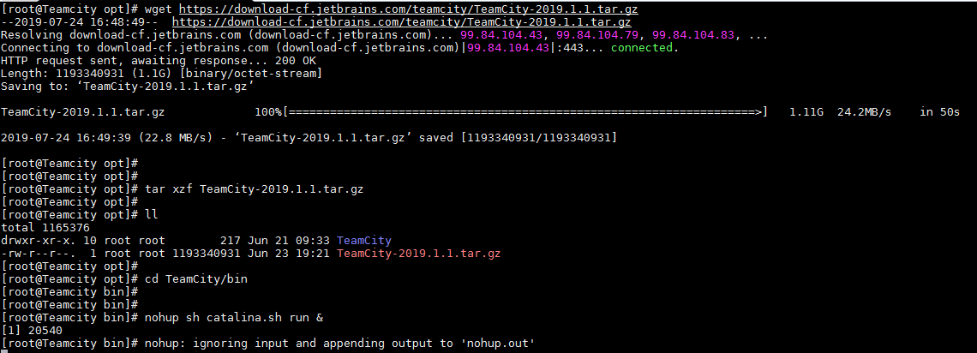

Access Teamcity Web Interface:

If everything went smoothly, you’ll be able to access TeamCity through [**http://<our IP address>:8111**](http://localhost:8111/) and you’ll see the following pages:

Team city **UI** steps:

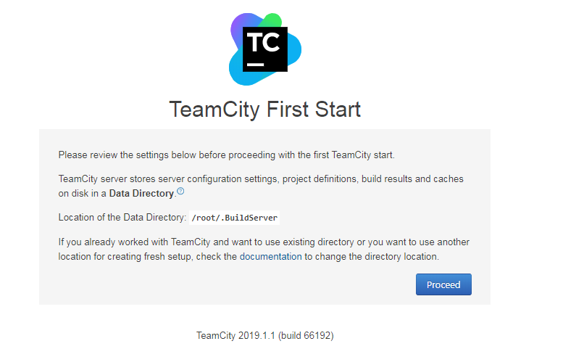

**proceed** with default database(HSQLDB)

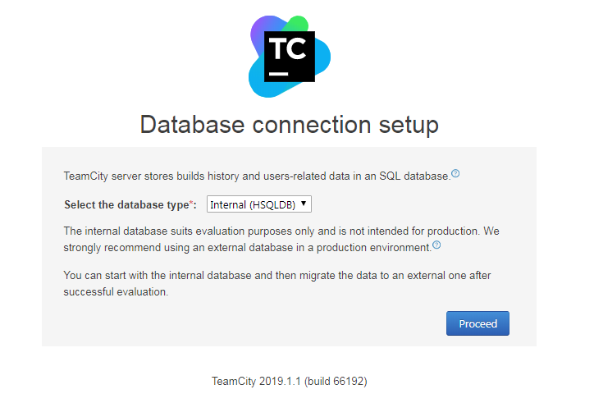

Now Accept the License Agreement

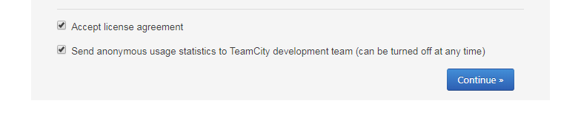

Create Administrator Account:

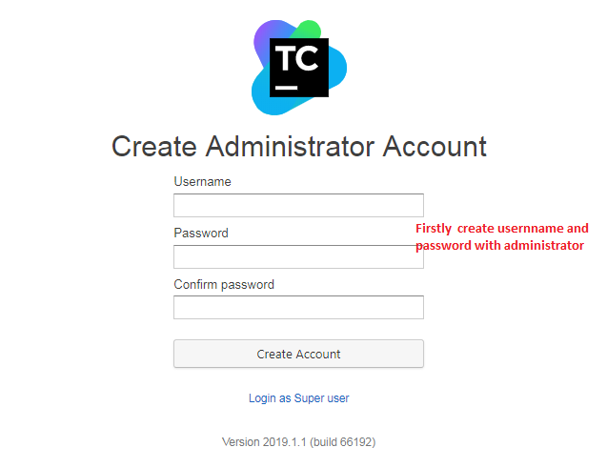

Now, you have completed TeamCity installation.

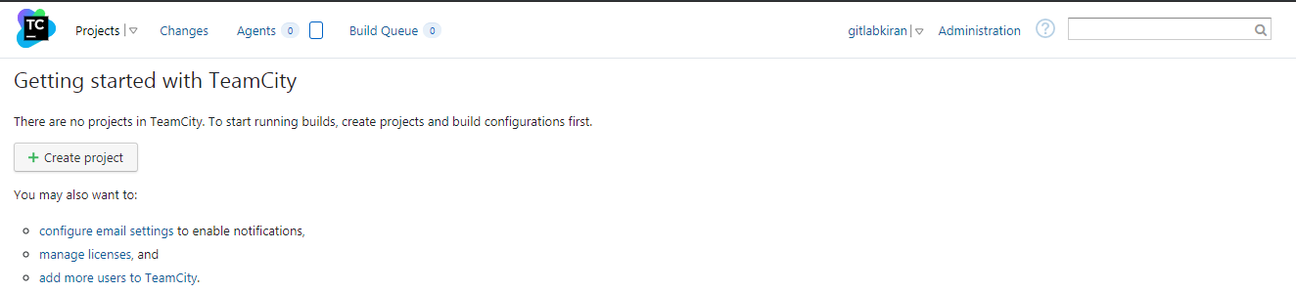

**Build Agent**

The Agent is responsible for the Build Configuration’s execution and you should install at least one Agent so you can work with TeamCity.

**Build agent installation:**

Start by going to TeamCity » Agents (0) and click on Zip file distribution to download the Agent

And move (or) copy the build agent into teamcity server by using winscp

or

Go to downloads and copy the link and download into teamcity server

Unzip the file and move the directory to the location where you want TeamCity Agent or create a directory

mkdir <teamcityagent>

wget <build agent copied linkURL>

yum install -y unzip

unzip buildAgent.zip

Make Go to conf folder and rename the **buildAgent.dist.properties** and rename its to **buildAgent.properties**.

cd conf/

mv buildAgent.dist.properties buildAgent.properties

Make the necessary adjustments to your configuration file **(buildAgent.properties)**. I’ll leave it as it is since I want to install TeamCity Agent on the same machine as TeamCity and I haven’t changed the default URL (which is [**http://<our ip address>:8111**](http://localhost:8111/)) and the agent name

vi buildAgent.properties

Set execution permissions to the script that starts the Agent

cd bin/

sudo chmod 777 agent.sh

Start the Agent

sh agent.sh start

Screen Shots for BuildAgent installation:

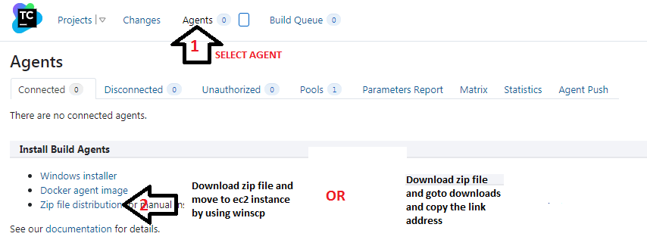

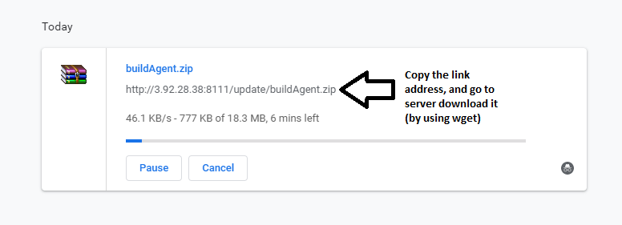

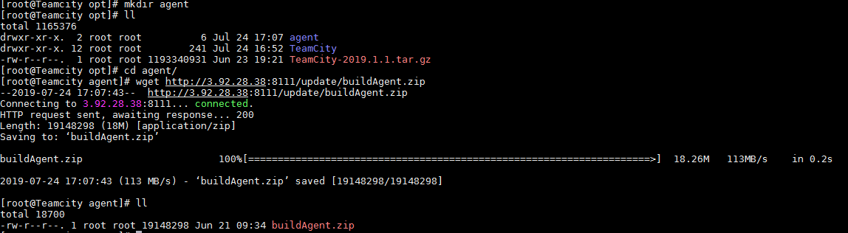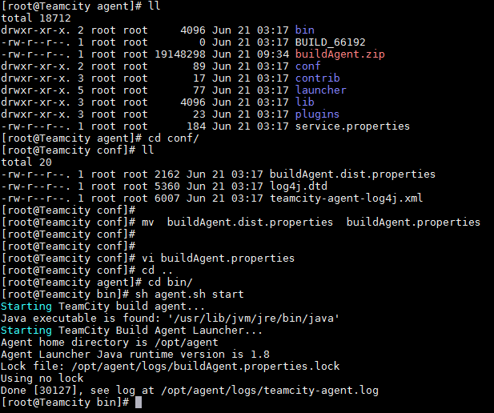

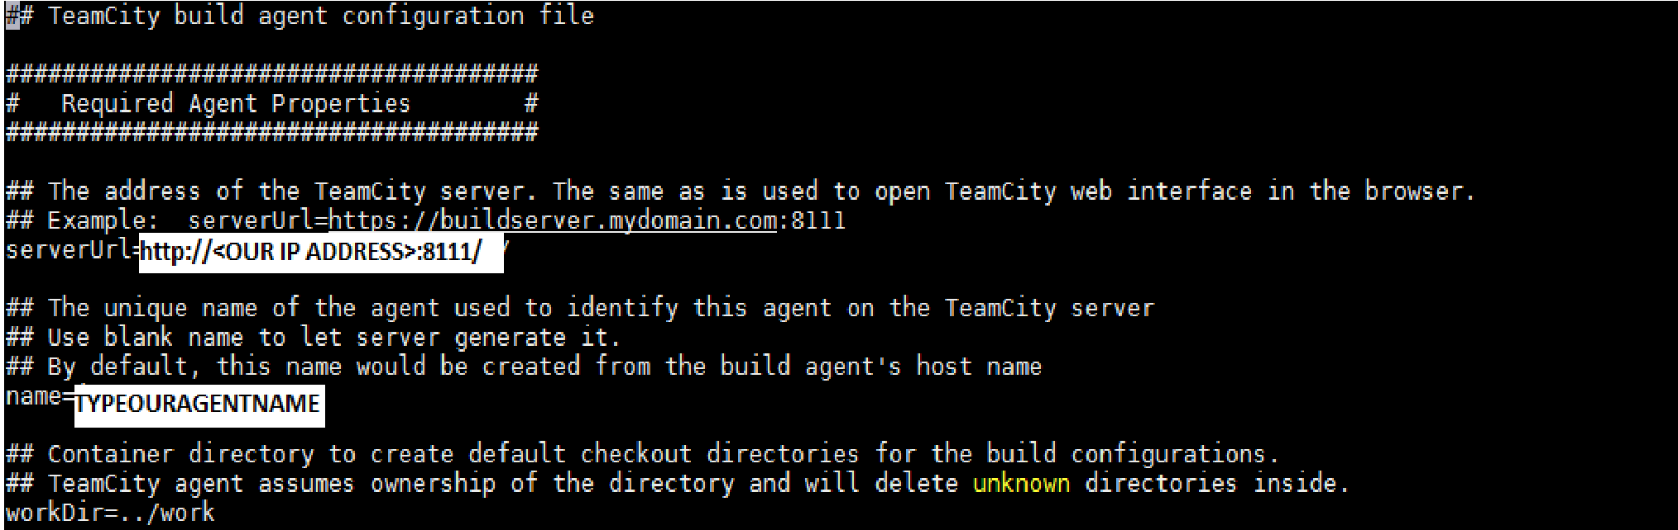

Go back to TeamCity’s page in your browser and you should see you one agent in the Disconnected tab and Automatically it will connected you should see it in the Connected tab

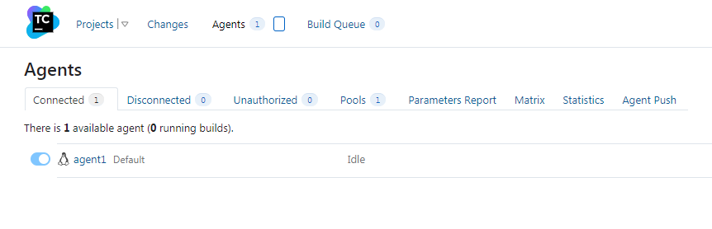

**Creating a CI/CD Pipeline in Teamcity**

**Software requirements:**

Java, Maven and Docker

**Maven Installation:**

wget http://www-eu.apache.org/dist/maven/maven-3/3.5.4/binaries/apache-maven-3.5.4-bin.tar.gz

sudo tar xzf apache-maven-3.5.4-bin.tar.gz

sudo vi /etc/profile.d/maven.sh

export M2_HOME=/opt/apache-maven-3.5.4

export PATH=${M2_HOME}/bin:${PATH}

source /etc/profile.d/maven.sh

mvn -version

**Docker installation:**

yum-config-manager --add-repo https://download.docker.com/linux/centos/docker-ce.repo

yum install docker-ce-18.06.0.ce-3.el7 -y

service docker start

Create a Project

To create a Build Configuration go to TeamCity and create a new project through the Projects tab. Then click the Create project button, add the new project with a repository URL. Enter the URL and the authentication information for the source repository and click **Proceed**.

Next, TeamCity prompts for a project and build name. Accept the defaults and click **Proceed.**

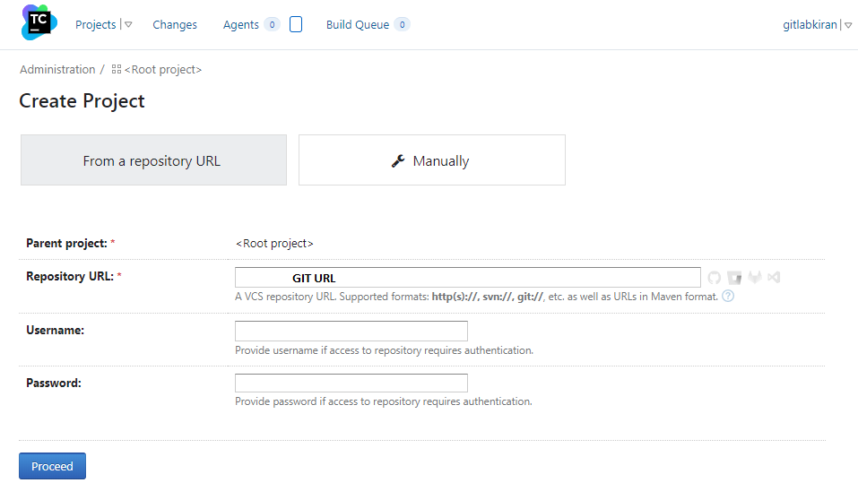

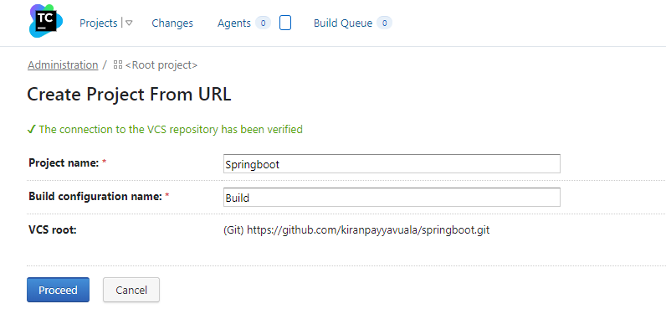

## TeamCity will check the project out and analyze the build script (****.travis.yml****) to determine how to build it. TeamCity supports Maven, Ant, or Gradle for Java. It works with MSBuild or Ant for .Net. It can also manage Ruby projects with Rake, as well as a variety of other build tools with other languages.

Let's start a build. Click the **Run**button on the upper right-hand side of the project page. or if you want add another build step left-hand side **Add build step** button.

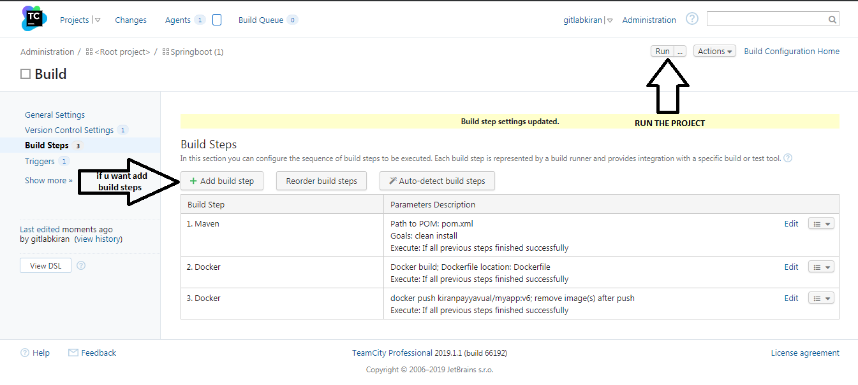

TeamCity build behavior is configurable. Click on **Edit Configuration Settings.** On the build configuration screen, click on **Show advanced options and select your new build type.**

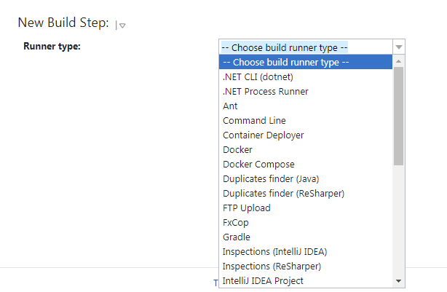

**For maven jar build(**depends on my .travis.yml**):**

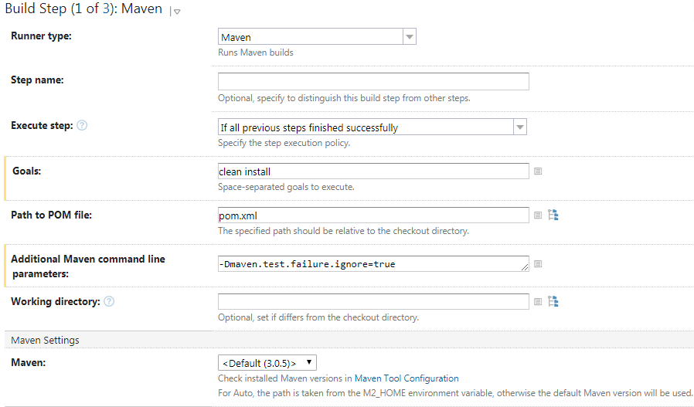

Docker image Building:

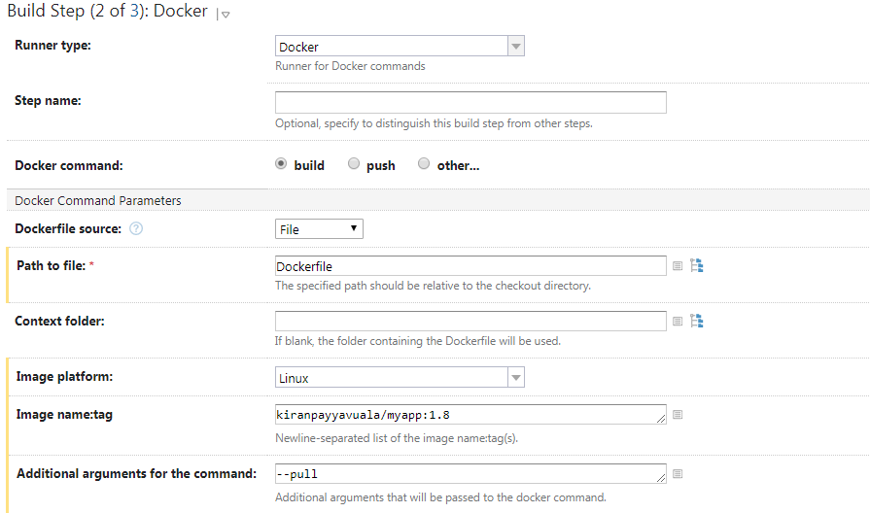

**Docker pushing to Docker hub:**

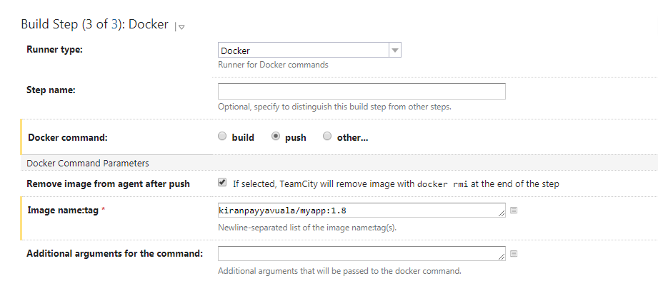

* We can also click the **Build Log, any Test cases and Artfacts**tag for a record of the build.

